

**DOCUMENTATION ON MAD PROJECT**

Name: Rutik Patel

Enrollment No: 18012011082

Sub: Mobile Application Development

Batch: MAD2

Title Of Project: Stopwatch

* Introduction:
* The purpose of this project is to implement a Java based stopwatch application that will allow users without an internet connection to track the fitness record.
* The users can start the Stopwatch and stop it anytime. It was originally invented by Samuel Watson. There is also a button to restart the stopwatch that will set the stopwatch to starting.
* The device is used when time periods must be measured precisely and with a minimum of complications. Laboratory experiments and [sporting events](https://en.wikipedia.org/wiki/Sporting_event) like [sprints](https://en.wikipedia.org/wiki/Sprint_(running)) are good examples.
* Purpose:
* A stopwatch is a timepiece designed **to measure the amount of time that elapses between its activation and deactivation**.
* The stopwatch function is also present in many electronic devices such as wristwatches, computers, cell phones, and portable music players.
* activity_main.xml

<?xml version="1.0" encoding="utf-8"?>

<LinearLayout

xmlns:android="http://schemas.android.com/apk/res/android"

xmlns:tools="http://schemas.android.com/tools"

android:layout_width="match_parent"

android:layout_height="match_parent"

android:orientation="vertical"

android:background="#C0E7EC"

android:padding="16dp"

tools:context="com.Rutvik.stopwatch.MainActivity">

<TextView

android:id="@+id/time_view"

android:layout_width="wrap_content"

android:layout_height="wrap_content"

android:layout_gravity="center_horizontal"

android:layout_marginTop="100dp"

android:background="@drawable/border"

android:textAppearance="@android:style/TextAppearance.Large"

android:textSize="50dp" />

<Button

android:id="@+id/start_button"

android:layout_width="wrap_content"

android:layout_height="wrap_content"

android:layout_gravity="center_horizontal"

android:layout_marginTop="50dp"

android:onClick="onClickStart"

android:text="@string/start" />

<Button

android:id="@+id/stop_button"

android:layout_width="wrap_content"

android:layout_height="wrap_content"

android:layout_gravity="center_horizontal"

android:layout_marginTop="50dp"

android:onClick="onClickStop"

android:text="@string/stop" />

<Button

android:id="@+id/reset_button"

android:layout_width="wrap_content"

android:layout_height="wrap_content"

android:layout_marginTop="50dp"

android:layout_gravity="center_horizontal"

android:onClick="onClickReset"

android:text="@string/reset" />

</LinearLayout>

* MainActivity.java

package com.rutvik.stopwatch;

import android.os.Bundle;

import android.app.Activity;

import android.os.Handler;

import android.view.View;

import java.util.Locale;

import android.widget.TextView;

public class MainActivity extends Activity {

private int sec = 0;

private boolean is_running;

private boolean was_running;

@Override

protected void onCreate(Bundle savedInstanceState)

{

super.onCreate(savedInstanceState);

setContentView(R.layout.activity_main);

if (savedInstanceState != null) {

sec = savedInstanceState.getInt("seconds");

is_running = savedInstanceState.getBoolean("running");

was_running = savedInstanceState .getBoolean("wasRunning");

}

running_Timer();

}

@Override

public void onSaveInstanceState(

Bundle savedInstanceState)

{

savedInstanceState.putInt("seconds", sec);

savedInstanceState.putBoolean("running", is_running);

savedInstanceState.putBoolean("wasRunning", was_running);

}

@Override

protected void onPause()

{

super.onPause();

was_running = is_running;

is_running = false;

}

@Override

protected void onResume()

{

super.onResume();

if (was_running) {

is_running = true;

}

}

public void onClickStart(View view)

{

is_running = true;

}

public void onClickStop(View view)

{

is_running = false;

}

public void onClickReset(View view)

{

is_running = false;

sec = 0;

}

private void running_Timer()

{

final TextView t_View = (TextView)findViewById(R.id.time_view);

final Handler handle = new Handler();

handle.post(new Runnable() {

@Override

public void run()

{

int hrs = sec / 3600;

int mins = (sec % 3600) / 60;

int secs = sec % 60;

String time_t = String .format(Locale.getDefault(), " %d:%02d:%02d ", hrs,mins, secs);

t_View.setText(time_t);

if (is_running) {

sec++;

}

handle.postDelayed(this, 1000);

}

});

}

}

* string.xml

<resources>

<string name="app_name">Rutvik Stopwatch</string>

<string name="start"> Start </string>

<string name="reset"> Reset </string>

<string name="stop"> Stop </string>

</resources>

* Border.xml

<?xml version="1.0" encoding="utf-8"?>

<shape xmlns:android="http://schemas.android.com/apk/res/android"

android:layout_width="match_parent"

android:layout_height="match_parent"

android:shape="rectangle">

<stroke

android:width="2dp"

android:color="#932424"

/>

</shape>

* Output
* Code In Studio

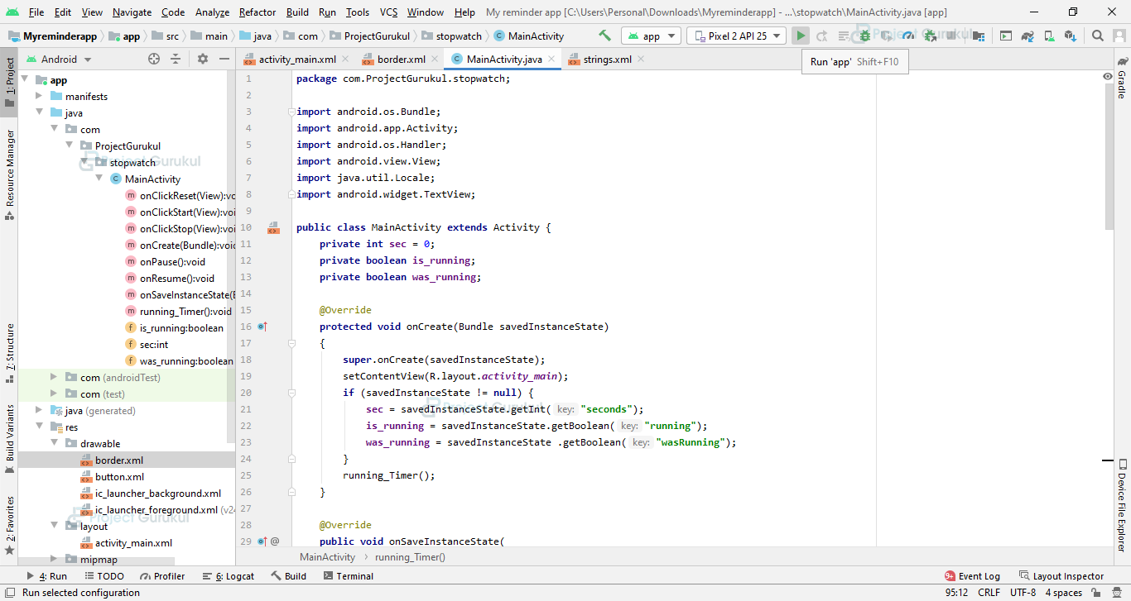

* Stopwatch

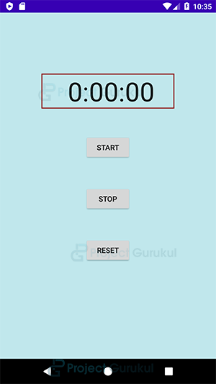

* Start

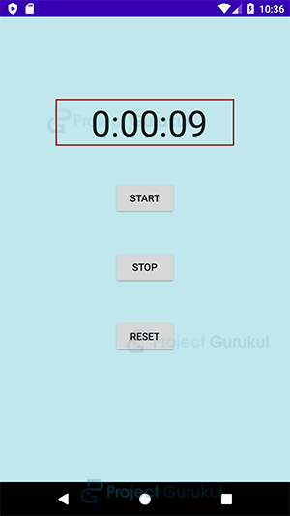

* Stop

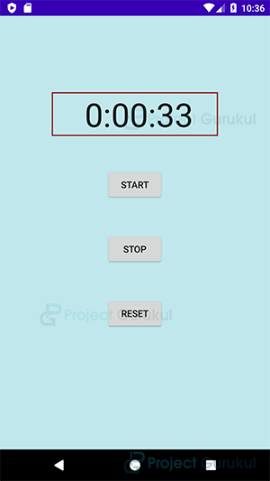

* Reset

